October content calendar – Talent Pool Pilot Initiative Campaign

W/C 10 October

Monday 10 | W/C 10 October
Post | Visual
FB  EU 🇪🇺 stands for:  🔹Democracy  🔹Freedom  🔹Equality  🔹Tolerance  🔹Solidarity  Together 🤝, we #StandWithUkraine 🇺🇦.  Today, EURES and @European Labour Authority are joining the @European Commission DG HOME and @EU Social as we launch the EU Talent Pool Pilot, a job-searching functionality tool on the EURES portal 💻, for people fleeing Ukraine and looking for a job in the EU. Keep following this channel to find out more ℹ️ and head over ⬇️  https://eures.ec.europa.eu/eu-talent-pool-pilot_en  today.  #EUTalentPoolPilot #EURESjobs #MigrationEU #StrongerTogether #EUsolidarityWithUkraine #EUspirit  (This will be reshared in FB story) | 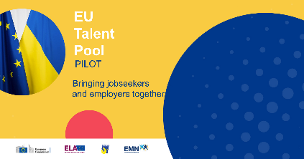
TW THREADS  1of2  EU 🇪🇺 stands for:  🔹Democracy  🔹Freedom  🔹Equality  🔹Tolerance  🔹Solidarity  Together, we #StandWithUkraine 🇺🇦.  2of2  Today, EURES and ELA are joining the @EU_Commission as we launch the EU Talent Pool Pilot initiative, with a job-searching functionality tool on the EURES portal 💻, for people fleeing the war in Ukraine and looking for a job in the EU. Find out more⬇️  https://eures.ec.europa.eu/eu-talent-pool-pilot_en  #EUTalentPoolPilot #EURESjobs #EUsolidarityWithUkraine | Tags on image: @EU_ELA, @EUHomeAffairs, @EU_Social
LI

EU stands for: Democracy, Freedom, Equality, Tolerance, Solidarity.

Together, we #StandWithUkraine.

Today, EURES joins the @European Commission as we launch the EU Talent Pool Pilot initiative, with a job-searching functionality tool on the EURES portal, for people fleeing the war in Ukraine and looking for a job in the EU. Keep following this channel to find out more and head over ⬇️
https://eures.ec.europa.eu/eu-talent-pool-pilot_en
today.

@European Labour Authority #EUTalentPoolPilot #EURESjobs #MigrationEU #EUsolidarityWithUkraine #StrongerTogether #EUspirit

IG  EU 🇪🇺 stands for:  🔹Democracy  🔹Freedom  🔹Equality  🔹Tolerance  🔹Solidarity  Together we #StandWithUkraine 🇺🇦.  Today, EURES joins the @europeancommission as we launch the EU Talent Pool Pilot initiative, with a job-searching functionality tool on the EURES portal 💻, for people fleeing the war in Ukraine and looking for a job in the EU. Keep following this channel to find out more ℹ️ and head over 🔗 Link in bio and first comment.  #EUTalentPoolPilot#EURESjobs #MigrationEU #StrongerTogether #EUsolidarityWithUkraine #EUspirit  FIRST COMMENT  Find out more⬇️  https://eures.ec.europa.eu/eu-talent-pool-pilot_en  #EUTalentPoolPilot #EURESjobs #EUsolidarityWithUkraine  (This will also be shared as a story) | 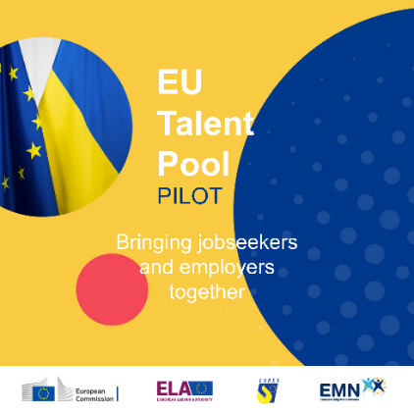
TELEGRAM

Today, EURES joins the European Commission as we launch the EU Talent Pool Pilot initiative, with a job-searching functionality tool on the EURES portal 💻, for people fleeing the war in Ukraine and looking for a job in the EU. Keep following this channel to find out more.
Find out more

Tuesday 11

Post | Visual
Internal  Yesterday we launched the #EUTalentPoolPilot initiative on the EURES external channels, today we had the pleasure to go in detail into the plan for the next 6 months during the CWG meeting.  ECO presented to the group about these topics: XXXX  This is the link to the Extranet with the PPT presentation and recordings, plus all the resources available so far, which you need to promote this campaign https://ec.europa.eu/eures/extranet/learn/file-repository/800-communication-workspace-documents-880-eures-campaigns/8807-eu-talent-pool  #EUTalentPoolPilot #EURESjobs #MigrationEU #StrongerTogether ##EUsolidarityWithUkraine #EUspirit | 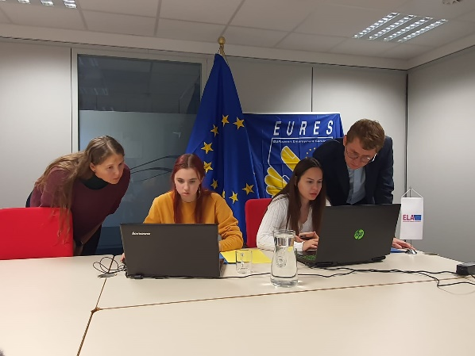  Alternative option, photo of Ukranian ladies uploading their CVs

Thursday 13

Post | Visual
FB  Thanks 🙏 to the #EUTalentPoolPilot, people fleeing the war in Ukraine 🇺🇦, are allowed to work 👨‍💼 in the EU 🇪🇺 under temporary protection. They can create their CV 📃 online and show their skills to more than 4 000 carefully validated and registered ✅ employers and EURES Members and Partners.  The EURES portal is safe 🔐to use: you can also choose not to disclose any personal data on your profile, i.e. your phone number, email address, address, name of previous employers and even your photo and name.  Register today ⬇️ https://eures.ec.europa.eu/eu-talent-pool-pilot_en  @European Labour Authority @EU Social  @European Commission #EURESjobs #MigrationEU #EUsolidarityWithUkraine #StrongerTogether #EUspirit | 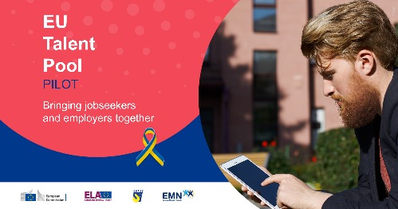
TW THREADS  1of2  Thanks 🙏 to the #EUTalentPoolPilot, people fleeing the war in Ukraine 🇺🇦, are allowed to work 👨‍💼 in the EU 🇪🇺 under temporary protection. They can create their CV 📃 online and show their skills to more than 4 000 validated and registered ✅ employers and EURES Members and Partners.  2of2  The EURES portal is safe 🔐to use: you can also choose not to disclose any personal data on your profile, i.e. your phone number, email address, address, name of previous employers and even your photo and name.  Register today ⬇️ https://eures.ec.europa.eu/eu-talent-pool-pilot_en  #EURESjobs #EUTalentPoolPilot #EUsolidarityWithUkraine | Tags on images: @EU_ELA, @EUHomeAffairs, @EU_Social,  @EU_Commission
LI

Thanks to the #EUTalentPoolPilot, people fleeing the war in Ukraine, are allowed to work in the EU under temporary protection. They can create their CV online and show their skills to more than 4 000 carefully validated and registered employers and EURES Members and Partners.

The EURES portal is safe to use: you can also choose not to disclose any personal data on your profile, i.e. your phone number, email address, address, name of previous employers and even your photo and name.

Register today ⬇️ https://eures.ec.europa.eu/eu-talent-pool-pilot_en

@European Labour Authority @European Commission #EUTalentPoolPilot #EURESjobs #MigrationEU #StrongerTogether #EUsolidarityWithUkraine #EUspirit

IG  Thanks 🙏 to the #EUTalentPoolPilot, people fleeing the war in Ukraine 🇺🇦, are allowed to work 👨‍💼 in the EU 🇪🇺 under temporary protection. They can create their CV 📃 online and show their skills to more than 4 000 carefully validated and registered ✅ employers and EURES Members and Partners.  The EURES portal is safe 🔐to use: you can also choose not to disclose any personal data on your profile, i.e. your phone number, email address, address, name of previous employers and even your photo and name.  Register today 🔗Link in bio and first comment.  @europeancommission #EUTalentPoolPilot #EURESjobs #MigrationEU #EUsolidarityWithUkraine #StrongerTogether #EUsolidarity #EUspirit  FIRST COMMENT  Find out more ⬇️ https://eures.ec.europa.eu/eu-talent-pool-pilot_en  #EURESjobs #EUTalentPoolPilot | 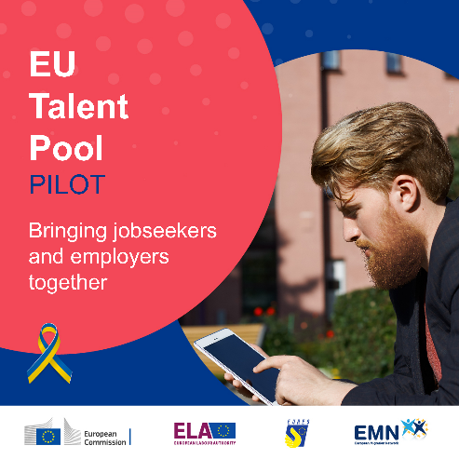
TELEGRAM

Thanks 🙏 to the EU Talent Pool Pilot, people fleeing the war in Ukraine 🇺🇦, are allowed to work 👨‍💼 in the EU 🇪🇺 under temporary protection. They can create their CV 📃 online and show their skills to more than 4 000 carefully validated and registered ✅ employers and EURES Members and Partners.

The EURES portal is safe 🔐to use: you can also choose not to disclose any personal data on your profile, i.e. your phone number, email address, address, name of previous employers and even your photo and name.

Register today

Monday 17 | W/C 17 October
Post | Visual
FB

#EUSolidarity 🤝 doesn’t stop. A new tool was created by @European Labour Authority and the @European Commission and it’s facilitated through the EURES portal 💻.

The #EUTalentPoolPilot allows people fleeing Ukraine 🇺🇦 to find a job in the EU 🇪🇺. Ask Advisers for information ℹ️, find out more on the EURES portal ⤵️ https://eures.ec.europa.eu/eu-talent-pool-pilot_en

@EU Social #EUTalentPoolPilot #EURESjobs #MigrationEU #StandWithUkraine #StrongerTogether #EUsolidarity #EUspirit

TW THREADS  1of2  #EUSolidarity 🤝 doesn’t stop. A new tool was created by @European Labour Authority and the @European Commission and it’s facilitated through the EURES portal 💻. The #EUTalentPoolPilot allows people fleeing Ukraine 🇺🇦 to find a job in the EU 🇪🇺.  1of2  Ask Advisers for information ℹ️, find out more on the EURES portal ⤵️ https://eures.ec.europa.eu/eu-talent-pool-pilot_en  #EUTalentPoolPilot #EURESjobs #MigrationEU #StrongerTogether #EUsolidarityWithUkraine #EUspirit | Tags on images: @EU_ELA, @EUHomeAffairs, @EU_Social
LI

#EUSolidarity doesn’t stop. A new tool was created by @European Labour Authority and the @European Commission and it’s facilitated through the EURES portal.
The #EUTalentPoolPilot allows people fleeing Ukraine to find a job in the EU. Ask EURES trained Advisers for information, find out more on the EURES portal ⤵️ https://eures.ec.europa.eu/eu-talent-pool-pilot_en

#EUTalentPoolPilot #EURESjobs #MigrationEU #StrongerTogether #EUspirit #EUsolidarityWithUkraine

IG  #EUSolidarity 🤝 doesn’t stop. A new tool was created by @European Labour Authority and the @European Commission and it’s facilitated through the EURES portal 💻.  The #EUTalentPoolPilot allows people fleeing Ukraine 🇺🇦 to find a job in the EU 🇪🇺. Ask EURES trained Advisers for information ℹ️, find out more on the EURES portal ⤵️  Link in Bio  #EUTalentPoolPilot #EURESjobs #MigrationEU #StandWithUkraine #StrongerTogether #EUsolidarity #EUspirit #EUsolidarityWithUkraine | 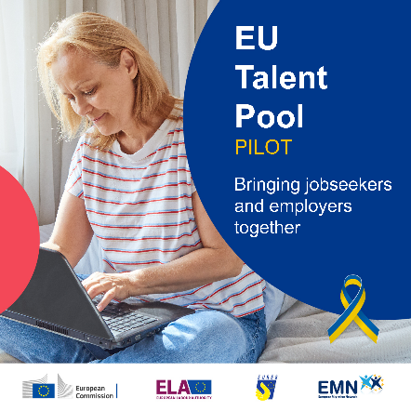
TELEGRAM

EU Solidarity 🤝 doesn’t stop. A new tool was created by @European Labour Authority and the @European Commission and it’s facilitated through the EURES portal 💻.

The EU Talent Pool Pilot allows people fleeing Ukraine 🇺🇦 to find a job in the EU 🇪🇺. Ask Advisers for information ℹ️, find out more on the EURES portal

Wednesday 19

Post | Visual
FB

The #EUTalentPoolPilot is a job-searching 🧑‍💼 tool on the EURES portal for people fleeing the war in Ukraine 🇺🇦 and looking 🔎 for a job in the EU 🇪🇺.

To check if you could be a beneficiary, and make the most of this tool, you need to register ✍️ on the EURES portal. But first you need to EU Login account. This step increases the security 🔐 of your account and data in the EURES portal.

It's very easy to get started with a EU Login account, follow these easy steps ⬇️ https://eures.ec.europa.eu/eu-talent-pool-pilot_en#how-to-register-on-the-eures-portal
@European Labour Authority @EU Social @European Commission
#EUTalentPoolPilot #EURESjobs #MigrationEU #StrongerTogether #EUsolidarityWithUkraine #EUspirit

TW THREADS  1of2  The #EUTalentPoolPilot is a job-searching 🧑‍💼 tool on the EURES portal for people fleeing the war in Ukraine 🇺🇦 and looking 🔎 for a job in the EU 🇪🇺.  To check if you could be a beneficiary, and make the most of this tool, you need to register ✍️ on the EURES portal.  2of2  But first you need to create a EU Login account. This step increases the security 🔐 of your data in the EURES portal.  It's very easy to get started with a EU Login account, follow these easy steps ⬇️ https://eures.ec.europa.eu/eu-talent-pool-pilot_en#how-to-register-on-the-eures-portal  #EUTalentPoolPilot #EURESjobs #EUsolidarityWithUkraine | Tags on images: @EU_ELA, @EUHomeAffairs, @EU_Social,  @EU_Commission
LI

The #EUTalentPoolPilot is a job-searching tool on the EURES portal for people fleeing the war in Ukraine and looking for a job in the EU.

To check if you could be a beneficiary, and make the most of this tool, you need to register on the EURES portal. But first you need to create a EU Login account. This step increases the security of your data in the EURES portal.

It's very easy to get started with a EU Login account, follow these easy steps ⬇️ https://eures.ec.europa.eu/eu-talent-pool-pilot_en#how-to-register-on-the-eures-portal

@European Labour Authority @European Commission #EUTalentPoolPilot #EURESjobs #MigrationEU #EUsolidarityWithUkraine #EUspirit
IG

The #EUTalentPoolPilot is a job-searching 🧑‍💼 tool on the EURES portal for people fleeing the war in Ukraine 🇺🇦 and looking 🔎 for a job in the EU 🇪🇺.

To check if you could be a beneficiary, and make the most of this tool, you need to register ✍️ on the EURES portal. But first you need to create a EU Login account. This step increases the security 🔐 of your account and data in the EURES portal.

It's very easy to get started with an EU Login account, follow these easy steps 🔗Link in Bio.
@europeancommission #EUTalentPoolPilot #EURESjobs #MigrationEU #StandWithUkraine #StrongerTogether #EUsolidarityWithUkraine #EUspirit

TELEGRAM

The EU Talent Pool Pilot is a job-searching 🧑‍💼 tool on the EURES portal for people fleeing the war in Ukraine 🇺🇦 and looking 🔎 for a job in the EU 🇪🇺.

To check if you could be a beneficiary, and make the most of this tool, you need to register ✍️ on the EURES portal. But first you need to create a EU Login account. This step increases the security 🔐 of your account and data in the EURES portal.

It's very easy to get started with an EU Login account, follow these easy steps ⬇️
More info here

Internal

We will reshare the FB post from the main EURES page with this text:
Don’t forget you play a key 🔑 role in the dissemination of the campaign, remember the many benefits to Ukrainian 🇺🇦 jobseekers 🧑‍💼 and European 🇪🇺 employers. Here are the resources uploaded to Extranet folder https://ec.europa.eu/eures/extranet/learn/file-repository/800-communication-workspace-documents-880-eures-campaigns/8807-eu-talent-pool

Monday 24 | W/C 24 October
Post | Visual
FB

Thanks to the Temporary Protection Directive, millions of people fleeing Ukraine🇺🇦 have found shelter in the EU🇪🇺.

If you benefit from temporary protection in a participating Member State, the #EUTalentPoolPilot initiative, facilitated through EURES, can help you find work💼.

Find out which countries are participating in the initiative⤵
https://eures.ec.europa.eu/eu-talent-pool-pilot_en#member-states-participating-in-the-eu-talent-pool-pilot

@European Labour Authority @EU Social @European Commission #EURESjobs #EUsolidarityWithUkraine #StrongerTogether #EUspirit #MigrationEU

TW  1 of 2  Thanks to the Temporary Protection Directive, millions of people fleeing Russian aggression against Ukraine🇺🇦 have found shelter in the EU🇪🇺.  If you benefit from it in a participating Member State, the #EUTalentPoolPilot initiative, facilitated through EURES, can help you find work💼.  2 of 2  Find out which countries are participating in the initiative⤵  https://eures.ec.europa.eu/eu-talent-pool-pilot_en#member-states-participating-in-the-eu-talent-pool-pilot  #EURESjobs #EUsolidarityWithUkraine | Tags on images: @EU_ELA, @EUHomeAffairs, @EU_Social,  @EU_Commission
LI

Thanks to the Temporary Protection Directive, millions of people fleeing he Russian aggression against Ukraine🇺🇦 have found shelter in the EU🇪🇺.

If you benefit from temporary protection in a participating Member State, the #EUTalentPoolPilot initiative, facilitated through EURES, can help you find work.

Find out which countries are participating in the initiative⤵
https://eures.ec.europa.eu/eu-talent-pool-pilot_en#member-states-participating-in-the-eu-talent-pool-pilot

@European Labour Authority @European Commission #EURESjobs #StandWithUkraine #StrongerTogether #EUsolidarityWithUkraine #EUspirit #MigrationEU

IG

Thanks to the Temporary Protection Directive, millions of people fleeing the Russian aggression against Ukraine🇺🇦 have found shelter in the EU🇪🇺.

If you benefit from temporary protection in a participating Member State, the #EUTalentPoolPilot initiative, facilitated through EURES, can help you find work💼.

Find out which countries are participating in the initiative 🔗 Link in bio.

@europeancommission #EURESjobs #StrongerTogether #EUsolidarityWithUkraine #EUspirit #MigrationEU

TELEGRAM

Tuesday 25

Post | Visual
Internal  On the 10 October EURES and the European Commission launched the #EUTalentPoolPilot initiative, and on the 11 October, ECO gave a presentation about this topic in the CWG meeting.  All assets are made available to the network on the Extranet https://ec.europa.eu/eures/extranet/learn/file-repository/800-communication-workspace-documents-880-eures-campaigns/8807-eu-talent-pool  Moreover, on the dedicated page on the EURES portal, you can find very important information about participating Member States: https://eures.ec.europa.eu/eu-talent-pool-pilot_en  #EURESjobs | Visual will be the reshare from FB

Saturday 29

Post | Visual
FB

If you are fleeing the war in Ukraine🇺🇦 or helping those who are, you must learn what the 🆕 #EUTalentPoolPilot initiative is about.

This tool was created to facilitate job searching🔎 in participating Member States for people benefitting from temporary protection in the EU 🇪🇺.

This is a safe tool: it allows to publish anonymised CV, accessible to trusted Advisers🗣, as well as to a selection of carefully validated and registered employers👔

If an employer wants to get in touch, they can do so through the EURES portal; they will not have access to contact details.

Find out more👇
https://eures.ec.europa.eu/eu-talent-pool-pilot_en#search-for-a-job-safely-and-fast-through-the-eures-portal

@European Labour Authority @EU Social @European Commission #EURSjobs #EUsolidarityWithUkraine #StrongerTogether #EUspirit #MigrationEU

TW

If you are fleeing the war in Ukraine🇺🇦 or helping those who are, meet the #EUTalentPoolPilot.

It’s a safe tool that facilitates job searching🔎 in participating Member States for those benefitting from temporary protection in the 🇪🇺

👉 https://eures.ec.europa.eu/eu-talent-pool-pilot_en#search-for-a-job-safely-and-fast-through-the-eures-portal

#EURSjobs
#EUsolidarityWithUkraine

LI

If you are fleeing the war in Ukraine or helping those who are, you must learn what the 🆕 #EUTalentPoolPilot initiative is about.

This tool was created to facilitate job searching in participating Member States for people benefitting from temporary protection in the EU.

This is a safe tool: it allows to publish anonymised CV, accessible to trusted Advisers🗣, as well as to a selection of carefully validated and registered employers.

If an employer wants to get in touch, they can do so through the EURES portal; they will not have access to email addresses.

Find out more👇
https://eures.ec.europa.eu/eu-talent-pool-pilot_en#search-for-a-job-safely-and-fast-through-the-eures-portal

@European Labour Authority @European Commission #EURSjobs #StandWithUkraine #StrongerTogether #EUsolidarityWithUkraine #EUspirit #MigrationEU

IG

If you are fleeing the war in Ukraine🇺🇦 or helping those who are, you must learn what the 🆕 #EUTalentPoolPilot initiative is about.

This tool was created to facilitate job searching🔎 in participating Member States for people benefitting from temporary protection in the EU 🇪🇺.

This is a safe tool: it allows to publish anonymised CV, accessible to trusted Advisers🗣, as well as to a selection of carefully validated and registered employers👔.

If an employer wants to get in touch, they can do so through the EURES portal; they will not have access to email addresses.

Find out more 🔗 Link in bio.

@europeancommission #EURSjobs #EUsolidarityWithUkraine #StrongerTogether #EUsolidarity #EUspirit #MigrationEU

TELEGRAM

If you are fleeing the war in Ukraine🇺🇦, you must learn what the 🆕 #EUTalentPoolPilot initiative is about.

This tool was created to facilitate job searching🔎 in participating Member States for people benefitting from temporary protection in the EU 🇪🇺.

This is a safe tool: it allows to publish anonymised CV, accessible to trusted Advisers🗣, as well as to a selection of carefully validated and registered employers👔.

If an employer wants to get in touch, they can do so through the EURES portal; they will not have access to email addresses.

Find out more.

#EURSjobs #EUsolidarityWithUkraine #StrongerTogether #EUsolidarity #EUspirit #MigrationEU

Tuesday 01 | W/C 01 November
Post | Visual
FB

Are you fleeing the war in Ukraine🇺🇦 and are looking for a job💼? There is a tool, created to help do exactly that.
It’s the #EUTalentPool, and it’s hosted on the EURES portal. By registering and uploading your CV📝, you will be able to present your skills and professional experience to more than 4️⃣0️⃣0️⃣0️⃣ carefully validated employers.

You will also have access to several hands-on🖐 information materials in English, Ukrainian and Russian.

Check them out⤵ https://eures.ec.europa.eu/eu-talent-pool-pilot_en#supporting-materials

@European Labour Authority @EU Social @European Commission #EURESjobs #EUsolidarityWithUkraine #StrongerTogether #EUspirit #MigrationEU #EUTalentPoolPilot

TW  1 of 2  Are you fleeing the war in Ukraine🇺🇦 and are looking for a job💼? There is a tool, created to help do exactly that.  It’s the #EUTalentPool, and it’s hosted on the EURES portal. By registering and uploading your CV📝, you will be able to present your skills and professional experience.  2 of 2  On the EURES portal, there are more than 4️⃣0️⃣0️⃣0️⃣ carefully validated employers.  You will also have access to several hands-on🖐 information materials in English, Ukrainian and Russian.  Check them out⤵ https://eures.ec.europa.eu/eu-talent-pool-pilot_en#supporting-materials  #EURESjobs #EUsolidarityWithUkraine #EUTalentPoolPilot | Tags on images: @EU_ELA, @EUHomeAffairs, @EU_Social,  @EU_Commission
LI

Are you fleeing the war in Ukraine and are looking for a job💼? There is a tool, created to help do exactly that.
It’s the #EUTalentPool, and it’s hosted on the EURES portal. By registering and uploading your CV📝, you will be able to present your skills and professional experience to more than 4,000 carefully validated employers.

You will also have access to several hands-on information materials in English, Ukrainian and Russian.

Check them out⤵ https://eures.ec.europa.eu/eu-talent-pool-pilot_en#supporting-materials

@European Labour Authority @European Commission #EURESjobs #EUsolidarityWithUkraine #StrongerTogether #EUspirit #MigrationEU #EUTalentPoolPilot

IG

Are you fleeing the war in Ukraine🇺🇦 and are looking for a job💼? There is a tool, created to help do exactly that.
It’s the #EUTalentPool, and it’s hosted on the EURES portal. By registering and uploading your CV📝, you will be able to present your skills and professional experience to more than 4️⃣0️⃣0️⃣0️⃣ carefully validated employers.

You will also have access to several hands-on🖐 information materials in English, Ukrainian and Russian.

Check them out 🔗 Link in bio.

@europeancommission #EURESjobs #StrongerTogether #EUsolidarityWithUkraine #EUspirit #MigrationEU #EUTalentPoolPilot

TELEGRAM

Are you fleeing the war in Ukraine🇺🇦 and are looking for a job💼? There is a tool, created to help do exactly that.
It’s the #EUTalentPool, and it’s hosted on the EURES portal. By registering and uploading your CV📝, you will be able to present your skills and professional experience to more than 4️⃣0️⃣0️⃣0️⃣ carefully validated employers.

You will also have access to several hands-on🖐 information materials in English, Ukrainian and Russian.

Check them out on the EU Talent Pool website.

#EURESjobs #StandWithUkraine #StrongerTogether #EUsolidarity #EUspirit #MigrationEU #EUTalentPoolPilot

Internal  [ Reshare from external channel with copy ]  #ICYMI: Today we shared an example of post aimed at people fleeing the war in Ukraine🇺🇦 on the EURES Jobs channels📱. If they are beneficiaries of temporary protection or adequate protection under national law, they are eligible to work in the EU 🇪🇺, and the #EUTalentPoolPilot initiative wants to help them achieve this.  Share the post below with your audiences🕸, and don’t forget to read this article about the campaign for more details🔎  [ link to the article which will be posted on 10 Oct ] | Visual will be the reshare
Thursday 03
Post | Visual
FB

The EURES portal has over 3️⃣ million published job vacancies. With the #EUTalentPoolPilot, as beneficiaries of temporary protection, people fleeing the war in Ukraine🇺🇦 can:

🔎 search through job vacancies, taking into account the country in which the temporary protection status is granted
📝 publish their CV in the EURES database
🗣 seek advice from Advisers

At the same time, employers across Europe can find their CVs.

Be mindful of fake employers🕵️‍♂️, and only trust official services like EURES. ℹ Information is available in English, Russian and Ukrainian.

Find out more⤵ https://eures.ec.europa.eu/pilotna-iniciativa-es-talent-pool-ukrainska_en

@European Labour Authority @EU Social @European Commission
#EURESjobs #MigrationEU #EUsolidarityWithUkraine #StrongerTogether #EUspirit

TW  1 of 3  The EURES portal offers over 3️⃣ million job vacancies.  With the #EUTalentPoolPilot, as beneficiaries of temporary protection, people fleeing the war in Ukraine🇺🇦 can search🔎 for job vacancies, considering the country in which the temporary protection status is granted.  #EUsolidarityWithUkraine  2 of 3  They can also:  📝 publish their CV in the EURES database  🗣 seek advice from Advisers  At the same time, employers across Europe can find their CVs.  #EUsolidarityWithUkraine  3 of 3  Be mindful of fake employers🕵️‍♂️, and only trust official services like EURES. ℹ Information is available in English, Russian and Ukrainian.  Find out more⤵ https://eures.ec.europa.eu/pilotna-iniciativa-es-talent-pool-ukrainska_en  #EURESjobs  #EUsolidarityWithUkraine | Tags on images: @EU_ELA, @EUHomeAffairs, @EU_Social,  @EU_Commission
LI

The EURES portal has over 3 million published job vacancies. With the #EUTalentPoolPilot, as beneficiaries of temporary protection, people fleeing the war in Ukraine can:

🔸 search through job vacancies, taking into account the country in which the temporary protection status is granted
🔸 publish their CV in the EURES database
🔸 seek advice from Advisers

At the same time, employers across Europe can find their CVs.

Be mindful of fake employers, and only trust official services like EURES. Information is available in English, Russian and Ukrainian.

Find out more⤵ https://eures.ec.europa.eu/pilotna-iniciativa-es-talent-pool-ukrainska_en

@European Labour Authority @European Commission #EURESjobs #MigrationEU #EUsolidarityWithUkraine #StrongerTogether #EUspirit

IG

The EURES portal has over 3️⃣ million published job vacancies. With the #EUTalentPoolPilot, as beneficiaries of temporary protection, people fleeing the war in Ukraine🇺🇦 can:

🔎 search through job vacancies, taking into account the country in which the temporary protection status is granted
📝 publish their CV in the EURES database
🗣 seek advice from Advisers

At the same time, employers across Europe can find their CVs.

Be mindful of fake employers🕵️‍♂️, and only trust official services like EURES. ℹ Information is available in English, Russian and Ukrainian.

Find out more 🔗 Link in bio.

@europeancommission #EURESjobs #MigrationEU #EUsolidarityWithUkraine #StrongerTogether #EUsolidarity #EUspirit

TELEGRAM

The EURES portal has over 3️⃣ million published job vacancies. With the #EUTalentPoolPilot, as beneficiaries of temporary protection, people fleeing the war in Ukraine🇺🇦 can:

🔎 search through job vacancies, taking into account the country in which the temporary protection status is granted
📝 publish their CV in the EURES database
🗣 seek advice from Advisers

At the same time, employers across Europe can find their CVs.

Be mindful of fake employers🕵️‍♂️, and only trust official services like EURES. ℹ Information is available in English, Russian and Ukrainian.

Find out more

#EURESjobs

